**B.Tech Program First Year**

**Course: Experiential Learning**

**Course Code: DA1001**

**“*License Plate Recognition System*”**

**By**

**Vedant Gupta(Reg No.- 219311013)**

**Niruj Agarwal(219311193)**

**Aditi Singh(219311171)**

**Under the Guidance**

**Of**

**Mr. VINOD KUMAR**

**Assistant Professor (Senior Scale)**

**Department of IT-School of Computing & IT**

**Manipal University Jaipur, Jaipur, Rajasthan – 303007**

**Department of IT**

**School of Computing & IT**

**Faculty of Engineering**

**July, 2022**

CERTIFICATE

This is to certify that the project titled “SMART ATTENDANCE” is a record of the bonafide work done by Vedant Gupta (Reg No. – 219311013), Niruj Agarwal(Reg No.-219311193) and Aditi Agarwal(Reg No.-219311171) submitted for the partial fulfilment of the requirements for the completion of the Experiential Learning (DA1001) course in the Department of Information Technology of Manipal University Jaipur, during the academic session March-July 2022.

________________________

Mr. Manoj Kumar

Associate Professor (Senior Scale)

Department of Computer and Communications Engineering

_________________________________

Dr. V. S. Dhaka

Associate Professor & Head of Department

Department of Computer and Communications Engineering

**Abstract**

Facial recognition is a way of identifying or confirming an individual’s identity using their face. Facial recognition systems can be used to identify people in photos, videos, or in real-time.Facial recognition is a category of [biometric security](https://www.kaspersky.com/resource-center/definitions/biometrics). Other forms of biometric software include voice recognition, fingerprint recognition, and eye retina or iris recognition. **Face recognition** method is used to locate features in the image that are uniquely specified. The project uses python programming. Face Recognition is a technology in computer vision. In Face recognition / detection we locate and visualize the human faces in any digital image.

Face Detection technology has importance in many fields like marketing and security. It’s very useful in pandemic times such as Covid-19 in hospitals and other fields.

Open CV has been used in this project. OpenCV is a Library which is used to carry out image processing using programming languages like python. This project utilizes OpenCV Library to make a Real-Time Face Detection using your webcam as a primary camera.  
**Following are the requirements for it:-** 

1. Python
2. OpenCV
3. Pillow
4. Numpy
5. OS
6. Csv
7. Pandas
8. Datetime
9. time

**Introduction**

Face detection is a process of detecting a human face or multiple human faces in a digital image or video. Face detection is a sub-process of facial recognition.

The basic model of how the project works is that if a person’s face is recognized by the camera(it needs to be stored in thedatabase with respective name and ID to be recognized), attendance of that person will be added with name and ID to a CSV file. If face is not recognized, there are no changes made in the CSV file and the face is detected as unknown.

This project uses**python programming and Open CV** to develop an attendance management system which identifies students using facial recognition and maintains a CSV file as output containing a record of students attending the class.

The major goal of this project is to create a facial recognition-based attendance monitoring system for educational institutions. In order to improve and update current attendance system information more efficiently than before. Furthermore, the present tools for attendance system are very intensive, making them inefficient and time consuming.

**Open CV** is an open-source library of python designed to solve computer vision problems. It is used to perform tasks like face-detection, objection tracking, landmark detection and much more. Open CV uses machine learning algorithms to search for faces within the picture.

NumPy is a python library used for working with arrays. It also has functions for working in domain of linear algebra, and matrices. NumPy is a fundamental package for scientific computing in Python which provides a muldimensional array object other mathematical operations can be performed using this but simply speaking we just

need it to convert our images into some form of array so that we can store the model that has been trained.

Goals - To help the lecturers, improve and organize the process of tracking and managing student attendance.

-Provides a valuable attentive service for both teachers and students.

- Reduce manual process errors by providing automated and a reliable attendance system.

- Increase privacy and security which, student cannot present him or his friend while they are not.

- Produce monthly reports for lecturers.

Flexibility, lectures capability of editing attendance records. -Reduce time loss as time is a very valuable resource.

**Literature Review**

1. In this paper, the idea of two technologies namely student Attendance and Feedback system has been implemented with a machine learning approach. This system automatically detects the student performance and maintains the student's records like attendance and their feedback on the subjects like Science, English, etc. Therefore, the attendance of the student can be made available by recognizing the face. On recognizing, the attendance details and details about the marks of the student is obtained as feedback.

2. Automated Attendance System using Face Recognition proposes that the system is based on face detection and recognition algorithms, which is used to automatically detects the student face when he/she enters the class and the system is capable to marks the attendance by recognizing him.

3. Student Attendance System Using Iris Detection:

In this proposed system the student is requested to standin front of the camera to detect and recognize the iris, for the system to mark attendance for the student. Some algorithms like Gray Scale Conversion, Six Segment Rectangular Filter, Skin Pixel Detection is being used to detect the iris. It helps in preventing the proxy issues and it maintains the attendance of the student in an effective manner, but in one of the time-consuming process for a student or a staff to wait until the completion of the previous members.

4.Face Recognition-based Lecture Attendance System:

This paper proposes that the system takes the attendance automatically recognition obtained by continuous observation. Continuous observation helps in estimating and improving the performance of the attendance. To obtain the attendance, positions and face images of the students present in the class room are captured. Through continuous observation and recording the system estimates seating position and location of each student for attendance marking. The work is focused on the method to obtain the different weights of each focused seat according to its location. The effectiveness of the picture is also being discussed to enable the faster recognition of the image.

EXISTING RECOGNITION SYSTEMS:

1. Fingerprint Based recognition system:

In the Fingerprint based existing attendance system, a portable fingerprint device need to be configured with the students fingerprint earlier. Later either during the lecture hours or before, the student needs to record the fingerprint on the configured device to ensure their attendance for the day. The problem with this approach is that during the lecture time it may distract the attention of the students.

2. RFID(Radio Frequency Identification) Based recognition system:

In the RFID based existing system, the student needs to carry a Radio Frequency Identity Card with them and place the ID on the card reader to record their presence for the day. The system is capable of to connect to RS232 and record the attendance to the saved database. There are possibilities for the fraudulent access may occur. Some are students may make use of other students ID to ensure their presence when the particular student is absent or they even try to misuse it sometimes.

3. Iris Based Recognition System:

In the Iris based student attendance system, the student needs to stand in front of a camera, so that the camera will scan the Iris of the student. The scanned iris is matched with data of student stored in the database and the attendance on their presence needs be updated. This reduces the paper and pen workload of the faculty member of the institute. This also reduces the chances of proxies in the class, and helps in maintaining the student records safe. It is a wireless biometric technique that solves the problem of spurious attendance and the trouble of laying the corresponding network.

4. Face Based Recognition System:

The facial recognition technology can be used

in recording the attendance through a high-resolution digital camera that detects and recognizes the faces of the students and the machine compares the recognized face with students’ face images stored in the database. Once the face of the student is matched with the stored image, then the attendance is marked in attendance database for further calculation. If the captured image doesn't match with the students face present in the database then this image is stored as a new image onto the database.

**Methodology**

Methodology followed to perform the study and obtain the results.

1. Problem Statement

Some challenges of facial recognition are discussed here:

The algorithms involved in the facial recognition are quite complex, which makes them highly inconsistent. The facial recognition system can show wrong data by showing different poses, and even similar looking people. The system might detect several false matches in a single frame. The software has to determine what the user intends to do, which is not an easy task for the software. The system requires very high computational power, which is why facial recognition systems are mostly used with high-end smartphones and laptops.

1. Proposed Solution Approach

The most significant issue with current biometric attendance systems is that they are frequently time consuming. As a result, our project will undoubtedly assist us in overcoming these time related issues.

•Facial recognition systems are easier to repair than biometric systems, as well as more cost effective.

•In the future, this project could be used to track individual employee attendance mistakes and help us improve an employee's working hours.

Covid-19 has taught the world today the importance and absolute necessity of sanitization and not coming into contact with anything foreign to your body. A fingerprint based biometric attendance scanner contradicts this very factor of personal safety. The facial recognition system gains much advantage in the safety criteria's because theirs's physical contact which can act as a problem.

Software and Hardware Required:

**Hardware used**:

Webcam

**Software used:**

Software installed-Python 3.10

Modules- Open CV,Pillow, face_regonition,os, dlib, NumPy, datetime,time

**Results And Discussions**

The main working principle of the project is that, the video captured data is converted into image to detect and recognize it. Further the recognized image of the student is provided with attendance, else the system marks the database as absent.

Capture video:

The Camera is fixed at a specific distance inside a classroom to capture videos of the frontal images of the entire students of the class.

Separate as frames from the video:

The captured video needs to be converted into frames per second for easier detection and recognition of the students.

Face Detection:

Face Detection is the process where the image, given as an input (picture) is searched to find any face, after finding the face the image processing cleans up the facial image for easier recognition of the face.

Face recognition:

After the completion of detecting and processing the face, it is compared to the faces present in the students' database to update the attendance of the students.

Post-Processing:

The post-processing mechanism involves the process of updating the names of the student into an excel sheet. The excel sheet can be maintained on a weekly basis or monthly basis to record the students' attendance. This attendance record can be sent to parents or guardians of students to report the performance of the student.

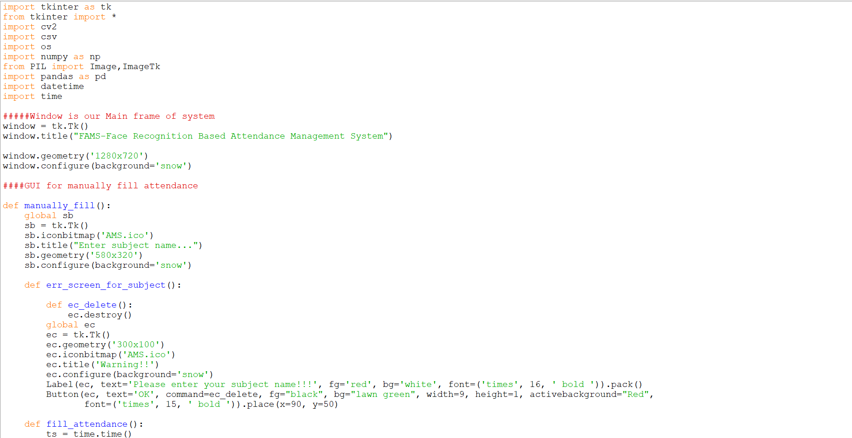

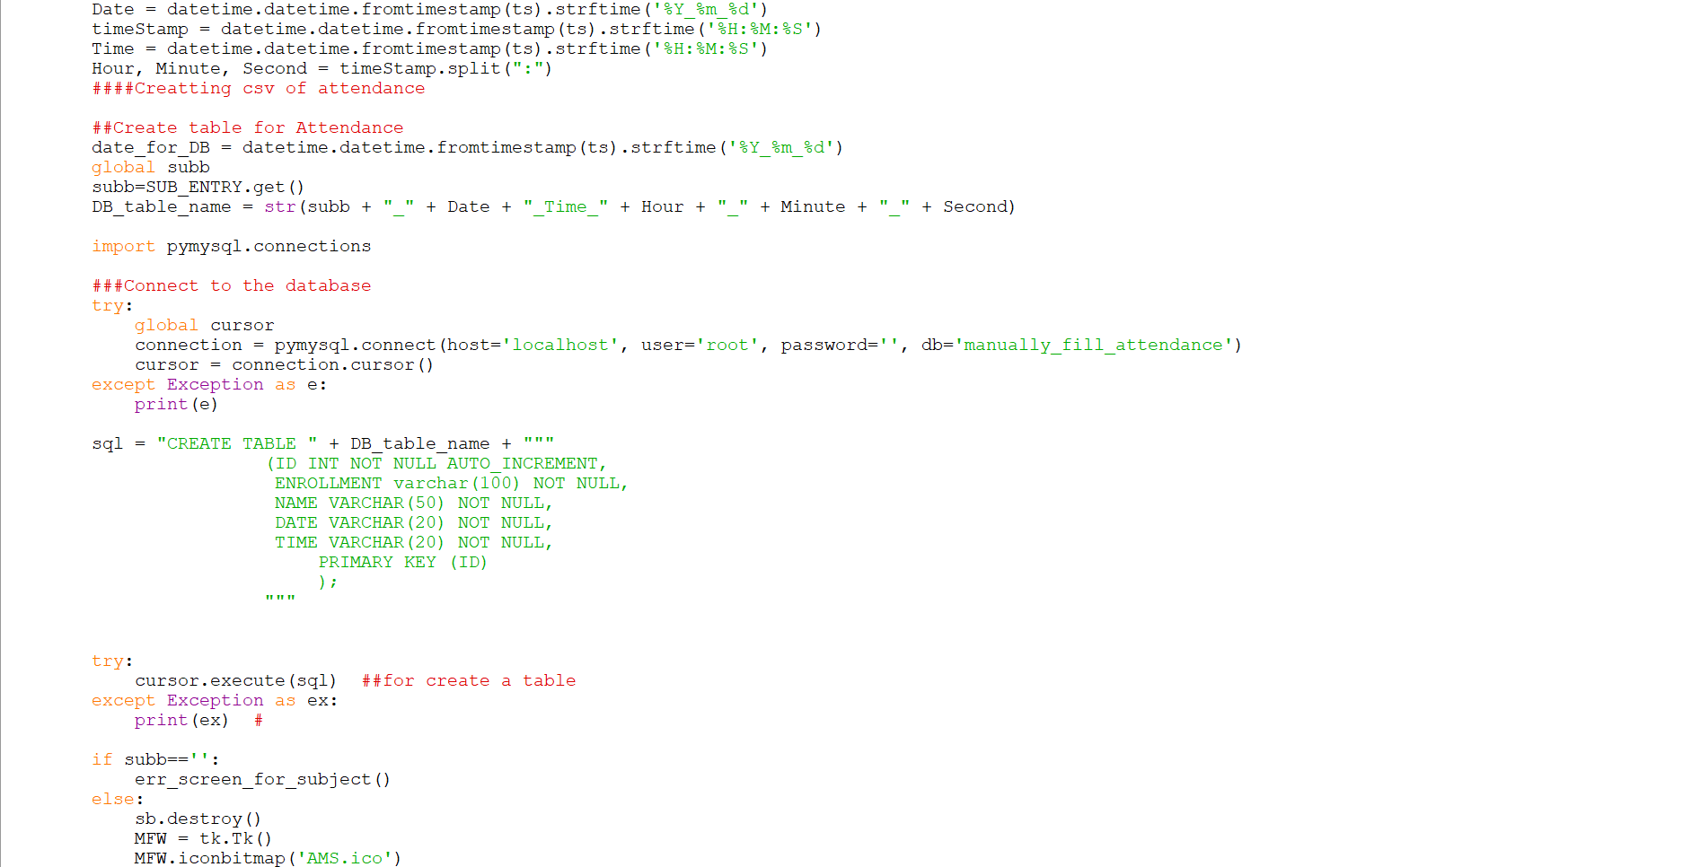

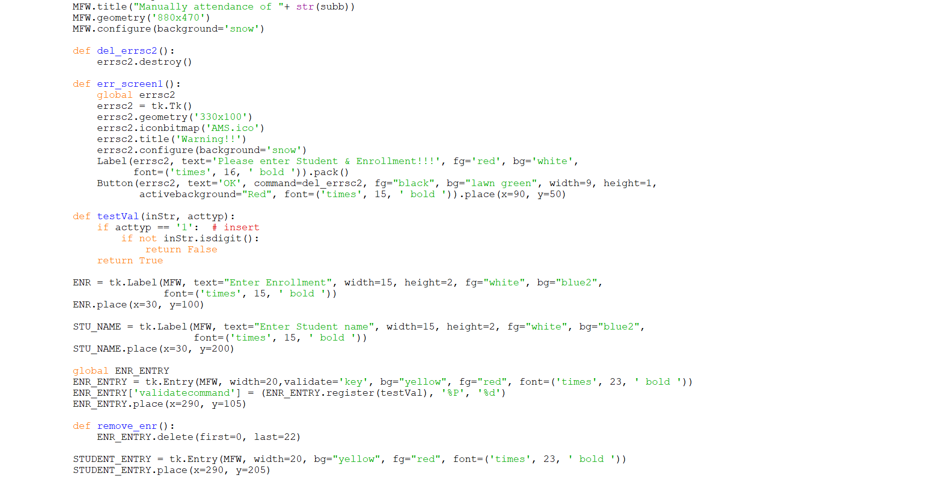

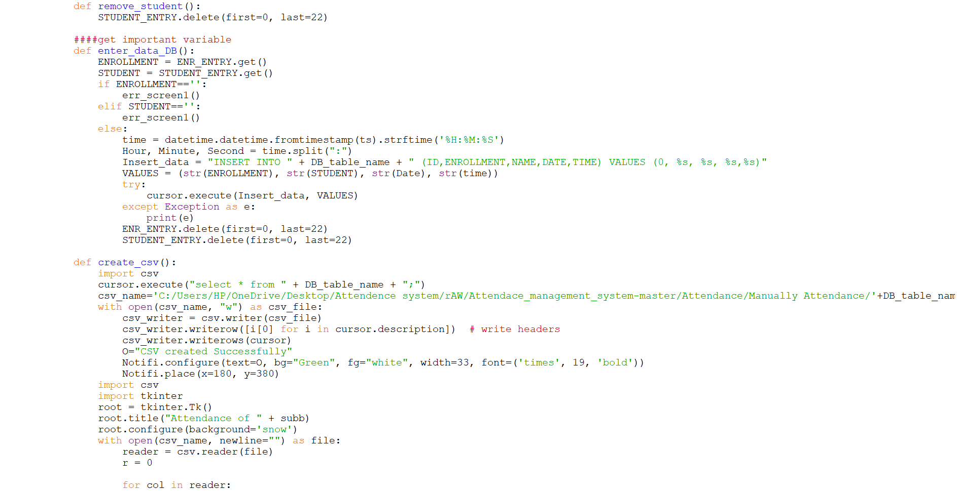

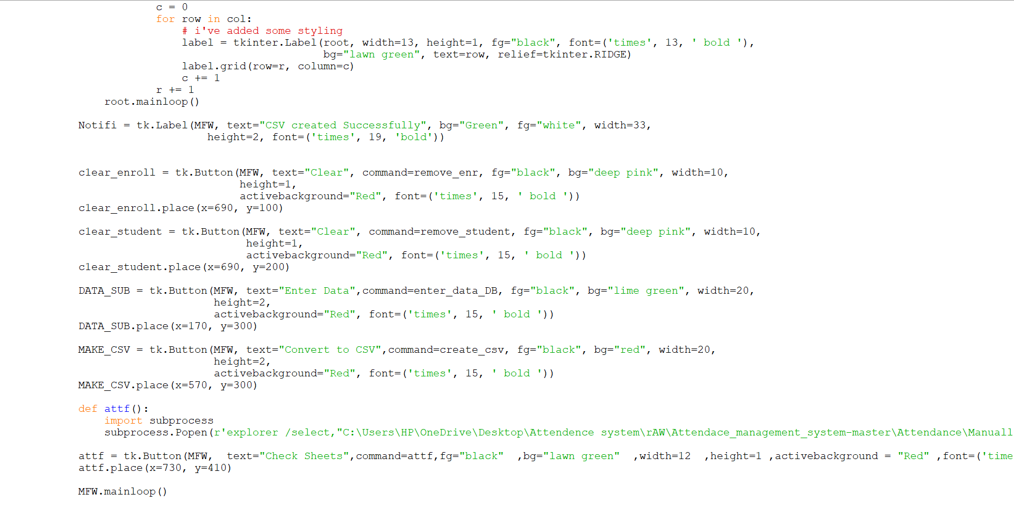

Output:

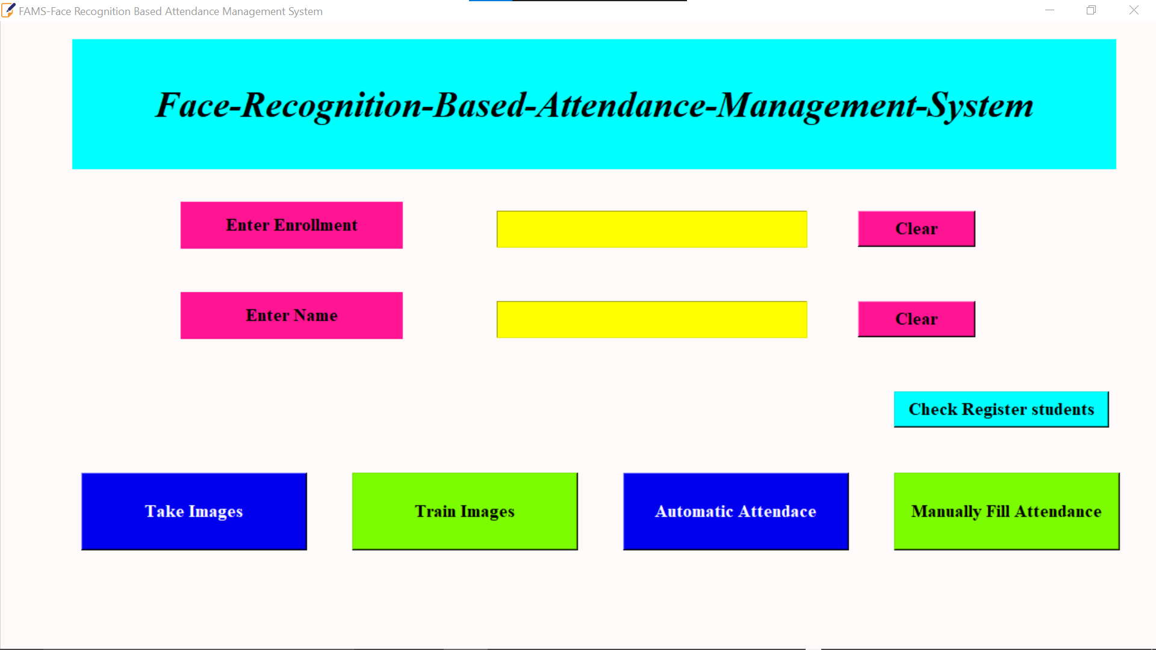

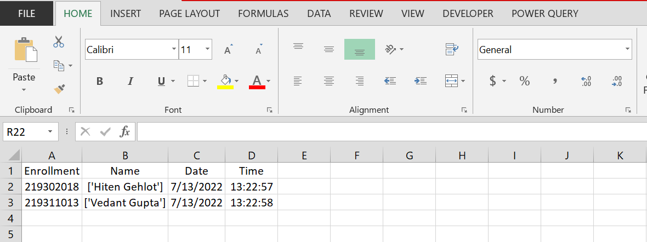

**Conclusion**

Face recognition technology has come a long way in the last twenty years. Attendance marking in a classroom during a lecture is not only a onerous task but also a time consuming one at that. Due to an unusually high number of students present during the lecture there will always be a probability of proxy attendance(s).Attendance marking with conventional methods has been an area of challenge. The growing need of efficient and automatic techniques of marking attendance is a growing challenge in the area of face recognition. In recent years, the problem of automatic attendance marking has been widely addressed through the use of standard biometrics like fingerprint and Radio frequency Identification tags etc., However,these techniques lack the element of reliability. In this proposed project an automated attendance marking and management system is proposed by making use of face detection and recognition algorithms. Instead of using the conventional methods, this proposed system aims to develop an automated system that records the student’s attendance by using facial recognition technology. The main objective of this work is to make the attendance marking and management system efficient, time saving, simple and easy. Here faces will be recognized using face recognition algorithms. The processed image will then be compared against the existing stored record and then attendance is marked in the database accordingly. Compared to existing system traditional attendance marking system, this system reduces the workload of people.

**Future Prospects**

There are numerous applications of facial recognition. They can be segmented into blacklist and whitelist applications. Blacklist applications include the ones related to security & surveillance and identification of criminals. All other applications such as attendance tracking, access control and others fall under the category of whitelist applications.

|  |  |
| --- | --- |
| **End-Use** | **Top  Applications** |
| **Offices** | Physical access to workspace facilities |
| **Government** | Helps to Identify missing children |
| **Banking and Telecom** | Help to know the current process to the customer, allow authentication of credit/debit cards |
| **Education** | Allow attendance tracking of the students and entry to labs |
| **Construction** | Control access to specific point at a site |
| **Real Estate Commercial** | Offers access to campus facilities like residence halls, common area, cafeteria, etc. |
| **Manufacturing** | Control and record access to specific locations for employees, visitors, vendors and maintenance staff |
| **Aviation** | Paperless travel at airports |
| **Warehouse** | Control process to provision entry and exit of vehicles |
| **Entertainment** | Access to multiplex cinema |

Earlier, this technology was only used for security and surveillance purposes, but it has safely transitioned to the real world in recent times. Today, companies are pitching facial recognition software as the future of everything from retail to policing.

Healthcare is one sector where we expect to see more countries adopting facial recognition to improve overall safety standards, reduce identification errors and improve the overall customer experience in environments such as hospitals and doctors’

Facial recognition technology is helping to reduce the spread of viruses like coronavirus by reducing the number of touchpoints in clinical environments and while this technology is being used to tackle the pandemic, moving into 2022 and beyond, the overall benefit of reducing the spread of viruses and pathogens means that digital healthcare and facial recognition are here to stay.

**References:**

**Refrences used in the study are as follows:**

1. C. Garcia and G. Tziritas, "Face detection using quantized skin color region merging and wavelet packet analysis," IEEE Transactions on Multimedia Vol.1, No. 3, pp. 264--277, September 1999.
2. H. Rowley, S. Baluja, and T. Kanade, “Neural Network-Based Face Detection,” IEEE Transactions on Pattern Analysis and Machine Intelligence, volume 20, number 1, pages 23- 38, January 1998.
3. M. Elad, Y. Hel-Or, and R. Keshet, “Pattern Detection Using a Maximal Rejection Classifier,” Pattern Recognition Letters, Vol. 23, Issue 12, pp. 1459-1471, October 2002
4. The Face Detection Homepage, <http://home.t-online.de/home/Robert.Frischholz/index>
5. Youtube
6. GitHub
7. [www.google.com](http://www.google.com)
8. [www.javapoint.com](http://www.javapoint.com)
9. Teachers
10. geekforgeeks.org

**Acknowledgements**

The satisfaction that accompanies the successful completion of this project would be incomplete without the mention of the people who made it possible, without whose constant guidance and encouragement would have made efforts go in vain.

I express my sincere gratitude to my project guide Mr. Rohit Kumar Gupta, Assistant Professor (Senior Scale) , Department of IT , without whose constant guidance and support the project would not be successful.

Finally, I would like to thank my relatives and friends who helped me a lot in finishing this assignment.

Vedant Gupta